Documentation

Contents

Windows 1

XAML Code 1

C# Code 1

Tables 1

## Windows

Main Window –

*MAIN WINDOW IMAGE*

The first thing I have done is created a main window where the user will be able to either log in, reset their password, or create an account from. The buttons are all highlighted differently to the background and the text is also offset from both versions of backgrounds. Brand name is also a different font to the more information-based text to differentiate easier.

Reset password window -

*RESET PASSWORD WINDOW IMAGE*

The reset password window is very similar to the login window, simple differences are the text indicating where the new password should go as well as a text block for confirming the new password for security purposes.

Register window –

*REGISTER WINDOW IMAGE*

The Registry window follows the same concepts as the previous two windows, simple difference is just the amount of text boxes due to the required info that must be stored.

## XAML Code

Main Window -

Reset password window -

Register window -

## C# Code

Universal in all windows –

*Lines 23 – 34*

In all windows beside the main window –



In all windows following the user logging in –

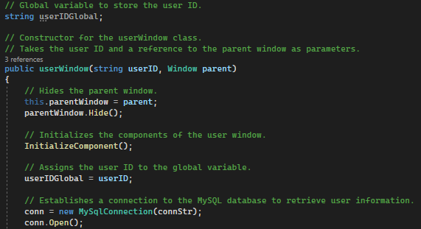

*Change to a customers window if needed*

Main window -

Reset password window -

Register window –

## Tables

Users table -

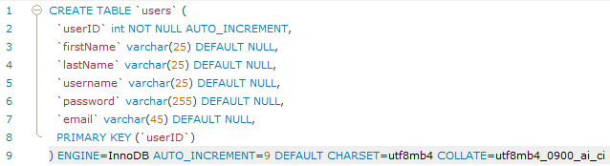

Customers table –

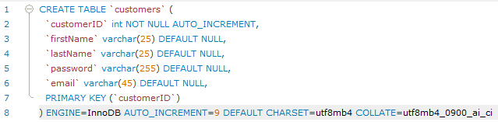

*Delete whichever isn’t relevant*